1. **Waste Disposal: Why Should E-Waste Be Recycled Correctly?**

Raise your hand if you've ever found yourself in this situation: your devices have reached the end of their useful life, and you need to buy new software. What are your plans for obsolete electronics? People frequently toss electronics in the garbage as a method of [electronic waste disposal.](https://recyclepro.co.uk/)

Unfortunately, electronic trash cannot simply be thrown away because of two factors:

* Old hardware can be extremely hazardous to the environment.
* These old devices contain sensitive information that makes you vulnerable to hackers

So, what's the solution to all of these e-waste disposal issues?

We'll explain why recycling your electronic garbage is a more ecologically friendly and secure solution, as well as how to properly dispose of it, in this post.

**The Environmental Impact of E-Waste Disposal**

The majority of hardware on the planet is made up of two primary components:

* Plastics
* Metals

The harsh reality is that when gadgets are discarded in landfills, both plastics and metals degrade in ways that might harm the environment. This includes the water, earth, plants, and animals in their immediate environment.

Let's look at the consequences of inappropriate e-waste disposal in more detail:

**Effects of Plastic Waste**

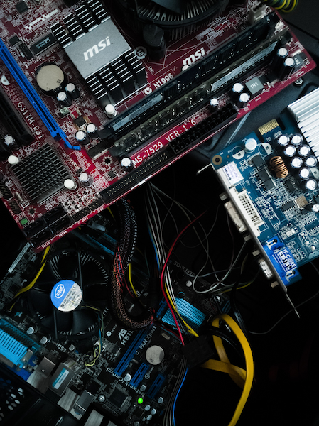

Plastics, for starters, are a big environmental problem since they do not decompose like other materials. They decompose into microplastic particles as they deteriorate.

Plants, animals, and fish are all harmed by microplastic particles. All of those food sources are consumed by humans, which means we are swallowing microplastics as well.

Microplastics have been found in the digestive tracts of fish, including species consumed by people, according to scientists. Given that people consume these fish, experts are unsure what effect microplastics will have on humans, but they are not positive.

**E Waste Metals Effect**

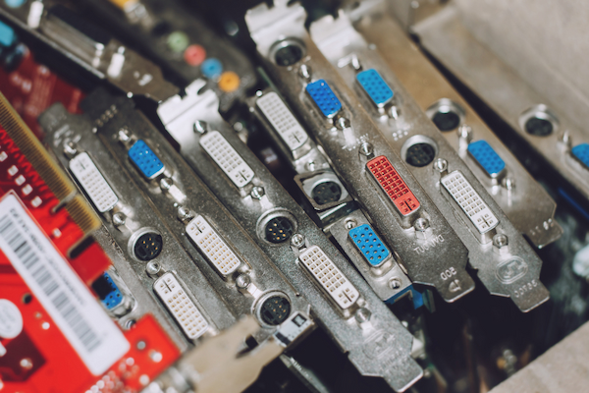

Next, each year, a variety of office hardware goods are simply thrown away in the trash, including:

* Computers
* Servers
* Wires
* Smartphones

Metals are found in almost all of these goods. When metals are left in landfills without being recycled, they oxidise and ionise in the soil (which means they are impacted by oxygen and break down).

Toxic compounds are generated when metals in electronic waste disposal devices, such as lead, cadmium, and mercury, break down. The bad news is that all of these metals are harmful to human health.

**Toxic E Chemicals Infiltrate Drinking Water**



These metals can seep into the environment and groundwater due to poor hazardous trash disposal. In fact, if such chemicals drain into the groundwater in large enough amounts, it can become deadly.

So, how can we address the environmental issues around this e-waste disposal conundrum?

The good news is that if businesses hired a reliable e trash disposal service like Recycle Pro, the environmental effect of hardware disposal might be reduced. As a result, electronic waste will be recycled in a safe and ecologically responsible manner.

Continue reading to understand how Recycle Pro can help you dispose of old devices while still preserving your important IT assets.

**Disposing of old IT assets poses a security risk**

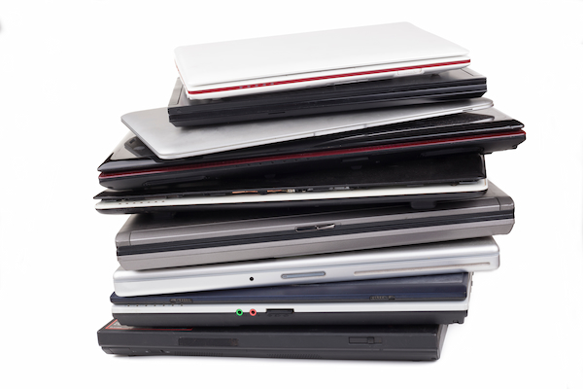

When you get rid of obsolete business gear, you're putting your company's security at danger.

In fact, according to a Blancco Technology Group analysis, 11 percent of 200 discarded hard drives still retained data on them. You might wonder how that's feasible.

Before they're ready for decommissioning, we anticipate the IT department to erase all devices. The IT department, on the other hand, lacks the means and resources to wipe all available data from a device before it leaves the company's premises.

**Hackers Have Access to Your Digital Information**

Data recovery solutions have improved throughout time, becoming more powerful and capable of recovering data from many devices. So, even if you've bolstered your digital security, if you don't use safe e-waste disposal practises, you're putting your organisation at risk.

If data remains on your devices after you've cleaned them, you're vulnerable in two ways:

* Hackers can get access to your company's IT infrastructure.
* Due to a breach, you're at risk of being sued.

Hackers can access the files and information you believed you had deleted using legal, widely accessible software. They can then enter your organisation and steal sensitive information, leaving you vulnerable to legal action.

**Breaches-Related Litigation Is Increasing**



Surprisingly, lawyers that specialise in data breach litigation had a busy year in 2020. The 2014 Anthem data breach resulted in one of the most famous settlements.

Due to the data breach that exposed the personal information of almost 79 million Anthem clients, more than three dozen states and the District of Columbia struck a deal with the health insurance company.

Anthem agreed to pay more than $39 million as part of the settlement. This payment comes on top of the $115 million fund Anthem was required to put up for credit monitoring of impacted clients.

**Data Breach Is Increasing Across the Globe**

Data breach lawsuits affect organisations all throughout the world, not only those based in the United States. Potential changes in UK legislation this year may make it simpler for attorneys to file class-action lawsuits on behalf of clients who have been harmed by data breaches.

Those corporations don't have to be British, though; the UK Supreme Court will consider an appeal in a lawsuit against Google in April 2021.

As you can see, failing to properly destroy data throughout the e trash disposal procedure puts you at danger for data breaches. No one can afford the penalties and poor publicity connected with a data breach, no matter how successful they are.

**Recycle Pro provides secure e-waste disposal**



If you're ready to retire IT assets like PCs, servers, and smartphones, it's time to contact Recycle Pro, a trustworthy e-waste disposal firm.

An [e-waste disposal firm](https://recyclepro.co.uk/) recycles outdated gear in a way that is both environmentally friendly and secure. You'll obtain a data destruction certificate indicating that your old IT assets have been recycled after the hardware has been properly disposed of.

[Recycle Pro](https://recyclepro.co.uk/) collaborates with your compliance officers to guarantee that you're doing your part to assist the environment while also adhering to the law. Please get in touch with us if you'd like to learn more.